**“to study of lipid profile in patients of type II Diabetes**

**Mellitus with and without hypothyroidism”**



Thesis Protocol submitted to Santosh University Ghaziabad

In partial fulfillment of the requirement for the award of

The degree of Doctor of Medicine (M.D)

**Submitted by**

Dr. Aditya Sharma

Post Graduate Student

Batch: 2017-2020

Department of Medicine

Santosh Medical College & Hospital Ghaziabad Santosh University, Ghaziabad

**DECLARATION BY THE CANDIDATE**

I hereby declare that this protocol titled” **To Study of Lipid Profile In Patients of Type II Diabetes Mellitus With and Without Hypothyroidism"** will be a bonafide genuine research carried out by me, under the esteemed able guidance of my guide.

Signature: _______________

Dr. Aditya Sharma

Post Graduate Student

Batch: 2017-2020

Department of Medicine

Santosh Medical College & Hospital

Ghaziabad – 201001 (U.P.)

Date

Place:

**CERTIFICATE BY THE GUIDE**

This is to certify that the protocol title "**To Study of Lipid Profile in Patients of Type II Diabetes Mellitus With and Without Hypothyroidism"** will be a bonafide genuine research carried out by Dr. Aditya Sharma, in partial fulfillment of the requirement for the degree of MD in the specialty of General Medicine.

Guide:

Dr. Ashok Kumar

M.B.B.S., M.D. (Medicine)

Associate Professor,

Department of Medicine

Santosh Medical College & Hospital

Ghaziabad (U.P.)

Date:

**CERTIFICATE BY THE HEAD OF THE DEPARTMENT**

This is to certify that the protocol title "**To Study of Lipid Profile in Patients of Type II Diabetes Mellitus With and Without Hypothyroidism"** will be a bonafide genuine research carried out by Dr. Aditya Sharma, in partial fulfillment of the requirement for the degree of MD in the specialty of General Medicine.

Head of the Department: _________________

Dr. M.K. Bhatnagar

M.B.B.S., M.D. (Medicine)

Professor and Head,

Department of Medicine

Santosh Medical College & Hospital

Ghaziabad (U.P.)

Date:

**Endorsement By The Dean Of The College**

This is to certify that the protocol title "**To Study of Lipid Profile in Patients of Type II Diabetes Mellitus With and Without Hypothyroidism"** will be a bonafide genuine research carried out by Dr. Aditya Sharma, in partial fulfillment of the requirement for the degree of MD in the specialty of General Medicine.

Signature: _________________________

Dr. Yogesh Tripathi

DEAN

Faculty of Medical Sciences

Santosh Medical College & Hospital

Ghaziabad

Date:

**INDEX**

|  |  |  |
| --- | --- | --- |
| S.NO. | Contents | Page number |
|  | Introduction | 8-9 |
|  | Aims and Objectives | 10 |
|  | Review of literature | 11-18 |
|  | Material and methods | 19-23 |
|  | Statistical analysis | 24 |
|  | Bibliography | 25-28 |
|  | Annexure | 29-35 |

**Introduction**

Diabetes Mellitus (DM) is a group of metabolic diseases characterized by increase blood glucose level resulting from defects in insulin secretion, insulin action, or both1.

The prevalence of diabetes mellitus is growing rapidly worldwide and is reaching epidemic proportions. The global prevalence of diabetes among adults is estimated to be 6.4%, affecting 285 million people in 2010 and is expected to increase to 7.7% affecting 439 million people by 20302. India has become the “diabetes capital” of the world with over three crore affected patients.3 Coronary artery disease, especially myocardial infarction is the leading cause of morbidity and mortality worldwide4.Hyperglycemia and atherosclerosis are related in type-2 diabetes5.

The prevalence of dyslipidemia in diabetes mellitus is 95%6. The dyslipidemia is a major risk factor for Coronary Heart Disease (CHD)7. The cardiovascular disease is a cause of morbidity and mortality in patients with diabetes mellitus because of disturbance in lipoproteins i.e. serum triglycerides (TC) 69%, serum cholesterol 56.6%, Low Density Lipoprotein cholesterol (LDL) 77% and High Density Lipoprotein cholesterol (HDL) 71%8,9.

 Today, however, the World Health Organization (WHO) and International Diabetes Federation (IDF) use the term “Metabolic Syndrome” to describe this clustering of conditions 10.

The term diabetic dyslipidemia comprises a triad of raised triglycerides, reduced high density lipoprotein (HDL) and excess of small, dense low density lipoprotein (LDL) particles. The lipid abnormalities are prevalent in diabetes mellitus because insulin resistance or deficiency affects key enzymes and pathways in lipid metabolism11.

Hypothyroidism is defined as a deficiency of thyroid activity, which results from reduced secretion of both T3 and T4 irrespective of the cause12.

It is the most common pathologic hormone deficiency among the endocrine disorders. Hypothyroidism may be due to primary disease of the thyroid gland itself or lack of pituitary TSH 13. Biochemically decrease in T4 and T3 concentrations lead to hypersecretion of pituitary TSH and an amplified increase in

serum TSH levels. This is a key laboratory finding, particularly in the early detection of thyroid failure14.

Clinically hypothyroidism may present with variety of symptoms and signs involving major systems of the body like endocrine, cardio vascular, central nervous system, musculoskeletal, hematological, reproductive, gastrointestinal and dermatological15. Thyroid hormones have significant effects on synthesis, mobilization and metabolism of lipids.

Overt hypothyroidism is associated with significant increase in circulating concentrations of total LDL-Cholesterol leading to coronary artery disease. Hypercholesterolemia is favored due to the hormone deficit and to the decreased activity of lipoprotein lipase16,17.

As there not much data available regarding the effects on lipid profile in patients with hypothyroidism in Type II diabetes mellitus in local population, hence there is a need to carry out such study in this population. So the aim of this study is to assess the effects on lipid profile in patients with hypothyroidism in Type II Diabetes mellitus.

Null hypothesis: we assume that lipid abnormalities are more in typeII diabetes with hypothyroidism than normal euthyroids subjects.

**AIMS AND OBJECTIVES**

**AIM:** To study of lipid profile in patients of Type II Diabetes Mellitus with and without Hypothyroidism.

**OBJECTIVES:**

1. To study lipid profile in Type II Diabetes Patients with Hypothyroidism.
2. To compare the lipid profile status of patients of only Type II Diabetes Mellitus with Patients having both Type II Diabetes and Hypothyroidism.
3. To compare the lipid profile status of patients of Type II diabetes and Subclinical Hypothyroidism with patients of Type II Diabetes and Overt Hypothyroidism.

**REVIEW OF LITERATURE**

Diabetes mellitus is a heterogeneous group of disorders associated with abnormal carbohydrate metabolism. It is a syndrome with disordered metabolism and inappropriate hyperglycemia due to either a deficiency of insulin secretion or to a combination of insulin resistance and inadequate insulin secretion to compensate.

Type 1 diabetes is due to pancreatic islet B cell destruction predominantly by an autoimmune process, and these patients are prone to ketoacidosis. Type 2 diabetes is the more prevalent form and results from insulin resistance with a defect in compensatory insulin secretion. Complications of diabetes are the result of metabolic, hormonal, environmental, and genetic factors, manifesting in every organ system18.

At present over 285 million people are living with diabetes across the globe. Among them as much as 90% are living with diabetes mellitus type 2, while the remaining manages diabetes type 1 daily with insulin dosage19. Once thought as a disease of the elderly, diabetes has shifted down a generation to affect people of working age, particularly in developing countries. This has economic consequences too.

Close to 4 million deaths in 20-79 age group may be attributable to diabetes in 2010, accounting for 6.8% of global all cause of mortality in this age group. The estimated number of premature deaths is similar to magnitude to deaths in this age group to several deaths due to infection in this age group. The number of deaths attributable to diabetes in 2010 shows a 5.5% increase over the estimates for the year 200719.

Lipid abnormalities associated with diabetes are termed as dyslipidemia rather than hyperlipidaemia because there may be changes in both quantity and quality of the lipoproteins. Diabetes mellitus (DM) is a common secondary cause of hyperlipidaemia, particularly, if glycaemic control is poor, which in-turn is an important risk factor for atherosclerosis and coronary heart disease.

**Effects of Insulin on Lipoprotein Metabolism**

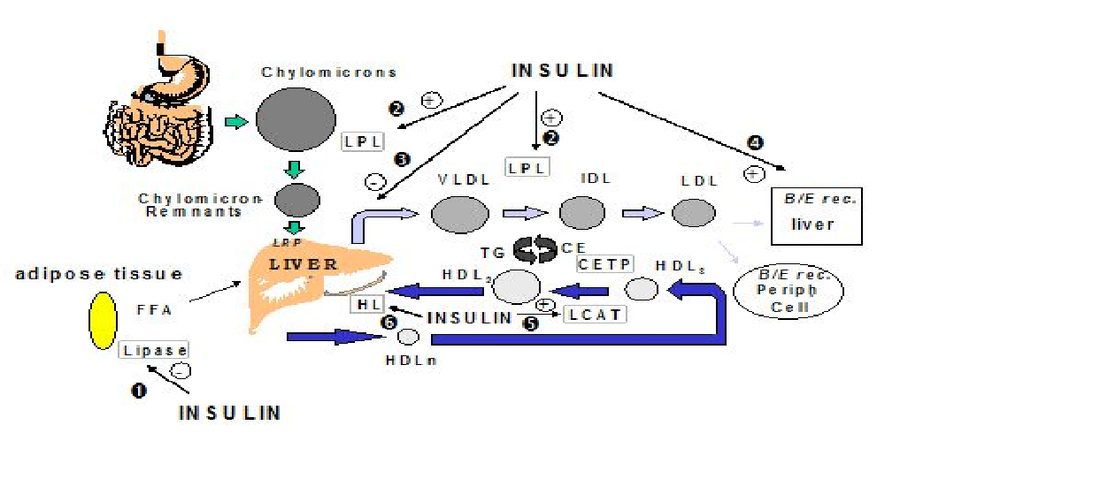

Figure 1

*VLDL: Very Low Density Lipoprotein; IDL: Intermediate Density Lipoprotein, LDL: Low Density Lipoprotein; HDL: High Density Lipoprotein; LPL: LipoProtein Lipase; HL: Hepatic Lipase; CETP: Cholesteryl ester Transfer protein; LCAT: lecithin-cholesterol acyl transferase; FFA: Free Fatty Acids ; B/E rec.: receptor B/E (LDL receptor); TG: Triglycerides; CE: Cholesterol Esters. 1: insulin inhibits hormone-sensitive lipase. 2 : insulin*

*activates LipoProtein Lipase (LPL). 3: insulin inhibits hepatic VLDL production. 4: insulin increases LDL B/E receptor expression. 5: insulin activates LCAT. 6: insulin activates Hepatic Lipase (HL).20*

**Effects of Insulin Resistance on Lipoproteinmetabolism**

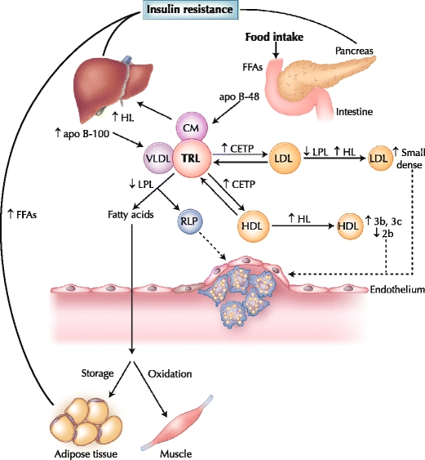

Figure 2

*Postprandial lipoprotein metabolism in diabetes. Insulin resistance plays a central role in the development of diabetic dyslipidemia. Under normal physiologic conditions, insulin suppresses lipolysis from adipose tissue and hepatic very low density lipoprotein (VLDL) production. However, hyperinsulinemia in the postprandial state and insulin resistance in type 2 diabetes initiates a dyslipidemic triad of high triglyceride, low high-density lipoprotein (HDL) cholesterol and high small, dense low-density lipoprotein (LDL) levels. Prolonged residence of triglyceride-rich lipoproteins (TRLs) in the circulation promotes the transfer of HDL or LDL cholesteryl esters for triglyceride, mediated by cholesteryl ester transfer protein (CETP). LDL can undergo hydrolysis by hepatic lipase (HL) or lipoprotein lipase (LPL), which hydrolyzes triglycerides from the core of LDL, resulting in production of smaller, denser particles. Moreover, triglyceride-enriched HDL particles become smaller, denser (HDL 3b and 3c) and are more rapidly catabolized, contributing to low plasma HDL in insulin resistance and type 2 diabetes. apo apolipoprotein; CM chylomicron; FFA free fatty acid; RLP remnant lipoprotein.21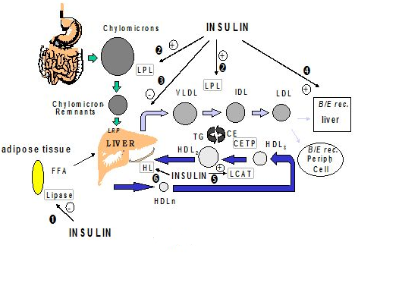*

Hypothyroidism is a common metabolic disorder in the general population. Indeed, data from the third National Health and Nutrition Examination Survey (NHANES III) showed a 4.6% prevalence of hypothyroidism in the general population, while 9.5% of the Colorado prevalence study participants had elevated levels of TSH 22 .

Thyroid failure is more common in women and its prevalence rises with age. Hypothyroid patients have increased levels of TC and LDL-C22. Indeed, hypothyroidism is a common cause of secondary dyslipidemia 23-24 .

A low serum Free T4 in conjunction with an elevated serum TSH level establishes the diagnosis of Overt Hypothyroidism25.

Subclinical hypothyroidism (SCH) is defined as a serum thyroid-stimulating hormone (TSH) level above the upper limit of normal despite normal levels of serum free thyroxine26. .

Thyroid dysfunction has a great impact on lipids as well as a number of other cardiovascular risk factors. Hypothyroidism is relatively common and is associated with an unfavorable effect on lipids.

Lipid disorders are common in diabetes mellitus and play crucial roles in the development of diabetic cardiovascular complications. Presence of thyroid dysfunction may affect diabetic control and thyroid disorders are known to influence on lipid metabolism.27

**Effects of Thyroid hormones on lipid metabolism**.

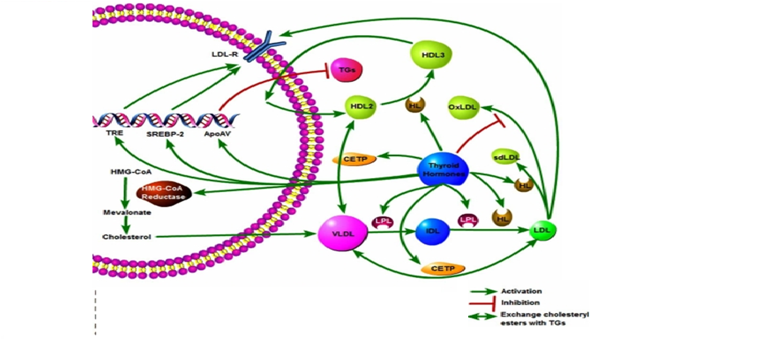

Figure 3

*Key:ApoAV:Apolipoprotein AV ,CETP:Cholesteryl ester transfer protein, HDL:High density lipoprotein, HL:Hepatic Lipase, HMG-CoA:3-hydroxy-3methylglutaryl-coenzymeA, IDL: Intermediary lipoprotein, LDL-R:LDL receptor, LPL:Lipoprotein lipase, OxLDL:OxidisedLDL,SREBP-2:sterol regulatory element-binding protein-2, VLDL:Very low density lipoprotein,TGs:Triglyceride, TRE:Thyroid response elements28*

Following are few studies showing relation of lipid abnormalities with Diabetes and relation of lipid abnormalities with hypothyroidism

**Nirmala et al (2016)** observed that majority of diabetic patients in the group with thyroid dysfunction were having abnormal lipid profile (73.3%). This value was found to be statistically significant with a p value of 0.0129.

**Bansal P et al (2017)** observed that the mean age of study and control group was51.7±9.9 and 50.5±9.7 respectively. The prevalence of dyslipidemia was significantly higher in study group than control group for all the lipid parameters. All the parameters of thyroid profile were significantly lower in study group. The prevalence of thyroid disorder in diabetic patients was 19%. Primary hypothyroidism was observed in 4 patients (31.6%), subclinical hypothyroidism in 9 (47.4%) patients, and subclinical hyperthyroidism in 6 (21.1%) patients30.

In a study done on lipid profile in ambulatory type 2 there was significant proportion of quantitative dyslipidaemia in the study population especially with the Total and LDL- cholesterols31.

In a comparative study: The patients with clinical hypothyroidism exhibited significant increase in concentration of total cholesterol, LDL and triglycerides, whereas HDL showed a decrease in its concentration in comparison to euthyroid controls. Subclinical hypothyroid patients revealed significant increase in concentration of total cholesterol, LDL and triglycerides level. Non significant decrease in HDL was observed in subclinical hypothyroid patients. They have found that hypothyroidism is associated with an atherogenic lipid and lipoprotein profile, characterized by an increase in concentration of total cholesterol, LDL and triglycerides and by decrease in HDL levels32-33.

**Maskey et al.** in a study of 271 subjects in Nepal described the prevalence of hypothyroidism (clinical and subclinical) in diabetics as 4.05% with female preponderance. Of the patients with abnormal thyroid profile 30.4% were clinically hypothyroid and 17.4% were subclinical hypothyroid. 4.3% patients had subclinical hyperthyroidism. High-density lipoprotein among different thyroid status was statistically significant 34.

**Zhang et al** concluded that TSH was positively associated with serum TC and LDL-C in euthyroid diabetic women 35.

A study done by **Shashi et al.** showed that there was a significant decrease in HDL levels and increase in LDL, triglycerides, VLDL levels in subclinical and overt hypothyroid diabetic patients36. According to the CDC, 97% of adults with diabetes have one or more lipid abnormalities while the prevalence of diabetic dyslipidemia varies from 25% to 60% in other studies (**Luboshitzky et al., 2002**)37.

In addition, some studies have shown that in SCH, dyslipidemia may also be accompanied by increased TGs (**Erdem et al., 2008**)38 and decreased HDL-C levels (**Efstathiadou et al., 2001**)39.

A study conducted by **V,Sunanda et al,2012** assessed the association between hypothyroidism and lipid levels. Serum lipid parameters of 75 patients with different levels of TSH (related to hypothyroidism) and 25 age and sex matched euthyroids as controls were evaluated in a cross sectional study. 75 cases of hypothyroidism in the age group of 20-60 years with 25 cases of age and sex matched euthyroids as controls were studied for thyroid profile over a period of 1 year and grouped on the basis of TSH levels as follows : Group I : 25 cases of normal healthy euthyroids as controls; Group II : 25 cases of TSH levels between 6-20 IU/ml; Group III : 25 cases of TSH levels between 21-40 IU/ml; Group IV : 25 cases of TSH level <40IU/ml, serum lipid profile parameters were analysed in all cases. They concluded that the effect of hypothyroidism on the serum concentrations of lipids is more marked in patients with higher serum TSH levels. Therefore the lipid abnormalities exhibited great individual variability, there might be a potential link between hypothyroidism and atherosclerosis40.

**MATERIALS AND METHODS**

**Place of Study:** Department of Medicine, Santosh Medical College and hospital, Ghaziabad on patients who will be attending the Medicine OPD of Santosh Hospital.

**Study design**: Case and Control Cross Sectional Study

**Study period**: From 1st Oct. 2017 to 31st Sept. 2018.

**Cases:** All diabetic patients attending Medicine OPD and IPD in the age group of 25-65 years will be subjected to History, Physical examination, Anthropometry, Routine investigations and Thyroid profile. After assessment these will be divided into three age and sex matched Groups as follows:

* Group 1- It will comprise of age and sex matched confirmed 25 cases of Type II Diabetes Mellitus.
* Group 2- It will comprise of age and sex matched confirmed 25 cases of Type II Diabetes Mellitus with Subclinical Hypothyroidism.
* Group 3- It will comprise of age and sex matched confirmed 25 cases of Type II Diabetes Mellitus with Overt Hypothyroidism.

**Control population**: The study will include age and sex matched 25 healthy subjects as Controls in the age group of 25 to 75 years.

**CRITERIA**

**Inclusion criteria:**

1. Criteria for the diagnosis of diabetes as per the American Diabetic Association are 41:

* HbA1C ≥ 6.5%
* Fasting Plasma Glucose ≥126 mg/dL (7.0 mmol/L).
* 2-hrs plasma glucose ≥ 200 mg/dL (11.1 mmol/L) during an Oral Glucose Tolerance Test.
* Random plasma glucose ≥ 200 mg/dL (11.1 mmol/L). Randomise defined as without regard to time since the last meal.

1. Criteria for diagnosis of Subclinical Hypothyroidism: Subclinical hypothyroidism is defined as a condition without typical symptoms of hypothyroidism, elevated TSH (>5 µU/mL), and normal circulating thyroid hormone (T3 and T4)42.
2. Criteria for diagnosis of overt hypothyroidism: Overt hypothyroidism is defined as a clinical syndrome of hypothyroidism associated with elevated TSH (>10Mu/l) and decreased serum levels of T4 (<4.5mcg/dl) or T3 (<80ng/dl)42.

**Exclusion criteria:**

* Patients with hepatic dysfunction-hepatitis and cholestasis.
* Patients with renal disease-nephrotic syndrome and chronic renal insufficiency.
* Patients with acute illness (sepsis, acute MI, severe heart failure, recent admission in intensive care unit).
* Gestational diabetes.
* Patients on treatment with drugs interfering with thyroid function(amiorone, propranolol, corticosteroids and oral contraceptives).
* History of total/ subtotal thyroidectomy, patients on I 131 treatment, lithium, antithyroid drugs, diagnosed cases of Grave’s disease, toxic multinodular goiter, toxic adenoma, carcinoma patients, gestational hyperthyroidism patients.
* Patients with history of chronic renal failure or radiation exposure.
* Patients with known liver, kidney or other acute and chronic diseases like tuberculosis etc.

**INVESTIGATIONS**

* Complete Haemogram
* FBS, PPBS
* HB1AC levels
* Thyroid profile-T3, T4, TSH
* Fasting Lipid profile-TC, TG, HDL, LDL, VLDL, Lipoprotein(a)
* Renal function tests-blood urea, serum creatinine, GFR(Cockcroft-Gault formula)
* Urine analysis for urine protein.
* Liver function tests
* Cardiovascular risk calculation (ACC/AHA/ASCVD)

**METHODOLOGY**

**Data Collection**

* An informed verbal consent would be taken from each and every patient.
* History will be taken from all diabetic patients and control subjects and complete general and systemic physical examination was performed. All patients and controls will be subjected to anthropometric measurements, routine and special investigations. Anthropometry includes measurement of weight( in kg), height(in cm), waist circumference (measured at the end of several consecutive natural breaths, at the level parallel to the floor, midpoint between the top of the iliac crest and the lower margin of the last palpable rib in midaxillary line.)43, hip circumference (Hip circumference was measured at a level parallel to floor, at the largest circumference of the buttocks), waist hip ratio (calculated by dividing WC in cm by hip circumference in cm)44. BMI (weight in kilograms divided by the square of the height in meters.)45.
* Cut off points for waist-hip ratio for Asians used (0.95 in men and 0.80 in women) denote abdominal obesity.46
* BMI cut off points (Asian) as follows; BMI <18.5 kg/m² (lean or underweight), between 18.5 and 22.9 kg/m² (normal), between 23 and 27.49 kg/m² (overweight) and 27.5 kg/m² or above as (obese).47
* Routine investigations include haemoglobin, total leukocyte count, blood urea, serum creatinine, fasting and postprandial blood glucose levels, uric acid and liver function tests. Special investigation includes glycosylated haemoglobin, T3, T4, TSH and lipid profile [TG, TC, HDLC, LDLC, VLDLC]

**STATISTICAL ANALYSIS**

To collect required information from eligible patients a pre-structured pre-tested Performa will be used. For data analysis Microsoft excel and statistical software SPSS version 24 will be used and data will be analyzed with the help of frequencies, figures, proportions, measures of central tendency, appropriate statistical test like Chi-square test and ANOVA test.

**BIBLIOGRAPHY**

1. Kishore J. National programme for control of diabetes, CVD and stroke. In: Kishore J, eds. National Health Programme of India. 9th ed. New Delhi: Century Publications; 2011: 480-489.
2. Shaw JE, Sicree RA, Zimmet PZ. Global estimates of the prevalence of diabetes for 2010 and 2030. Diabetes Res Clin Pract. Elsevier; 2010;87(1):4-14.
3. Vinu Vij, Pallavi Chitnis, Vijay Kumar Gupta. Evaluation of thyroid dysfunction among type II diabetic patients. International Journal of Pharmacy and Biological Sciences Oct- Dec 2012; 2(4): 150-155.
4. Roberto T, Dodesini AR, Lepore G. Lipid and renal disease. J Am Soc Nephrol. 2006;17:145-7
5. Devrajani BR, Shah SZ, Soomro AA, Devrajani T. Type 2 diabetes mellitus: a risk factor for Helicobacter pylori infection: a hospital based casecontrol study. Int J Diabetes Dev Ctries. 2010;30(1):22-6.
6. Chattanda SP, Mgonda YM. Diabetic dyslipidemia among diabetic patients attending specialized clinics in Dar es Salaam. Tanzania Med J. 2008;23(1):08- 11.
7. Krishna P, Roopakala, Prasanna KM. Dyslipidemia in type 1 diabetes mellitus in the young. Int J Diabetes Dev Ctries. 2005;25(4):110-2.
8. Khan SR, Ayub N, Nawab S, Shamsi TS. Triglyceride profile in dyslipidemia of type 2 diabetes mellitus. J Coll Physicians Surg Pak. 2008;18(5):270-3.
9. Gadi R, Samaha FF. Dyslipidemia in type 2 diabetes mellitus. Curr Diabetes Rep. 2007;7(3):228-34.
10. Zimmet P, Alberti G, Shaw J. A new IDF worldwide definition of the metabolic syndrome: the rationale and the results. Diabetes Voice. 2005;50(3):31–33.
11. Taskinen MR. Diabetic dyslipidemia. Atheroscler Suppl. 2002;3(1):47–51.
12. Shaikh BA. Clinical features of primary hypothyroidism : a year experience at Chandka medical college, Larkana. Medical Channel. 2008:14 (1) : 72-75.
13. Shaikh Z. Thyroid relted disorders at CHK. JCPSP. 1993; 3:26-8.
14. Galesanu C, Lisnic N, Teslara R, Apotsa L, Zbranca E. Lipid profile in a group of hypothyroid patients Vs treated hypothyroid patients. Rev. Med. Chir. Soc. Med. Nat. Lasi.2004; 108 (3): 554-560.
15. Toft A. Hypothyroidism. Med Intern 1989; 8:2596-2600.
16. Cappola AR , Ladenson PW. Hypothyroidism and atherosclerosis. Journal of Clinical Endocrinology . Metabolism .2003; 88:2438-2444.
17. Jawed S, Khawaja TF, Sultan A. Mahmood. Alterations in lipid profile in old age hypothyroid patients. Ann. King Edward Med. Coll. Sep. 2005; 11(3):311-313.
18. Wild S, Roglic G, Green A, Sicree R, King H. Global prevalence of diabetes, estimates for the year 2000 and projection for 2030. Diabetes Care. 2004;27:1047–53.
19. Diabetes Atlas. Fourth edition,IDF,2009.
20. Bruno Vergès (2011). Lipid Disorders in Type 1 Diabetes, Type 1 Diabetes - Complications, Pathogenesis, and Alternative Treatments, Prof. Chih-Pin Liu (Ed.), InTech, DOI: 10.5772/20869.
21. Postprandial Lipoproteins and Cardiovascular Disease Risk in Diabetes Mellitus Byambaa Enkhmaa & Zeynep Ozturk & Erdembileg Anuurad & Lars Berglund Published online: 27 January 2010 # The Author(s) 2010. This article is published with open access at Springerlink.com
22. Canaris GJ, Manowitz NR, Mayor G, Ridgway EC. The Colorado thyroid disease prevalence study. Arch Intern Med. 2000;160:526–34.
23. Tsimihodimos V, Bairaktari E, Tzallas C, Miltiadus G, Liberopoulos E, Elisaf M. The incidence of thyroid function abnormalities in patients attending an outpatient lipid clinic. Thyroid. 1999;9:365–8.
24. Stone NJ. Secondary causes of hyperlipidemia. Med Clin North Am. 1994;78:117–41.
25. Vaidya B, Pearce SH. Management of hypothyroidism in adults. BMJ 2008 AUG2;337:544-50.
26. Cooper DS. Subclinical hypothyroidism. N Engl J Med. 2001;345(4):260-265.
27. Makandar Asmabi, Sonagra Amit D, Biradar Shivaleela M and Quadri Shireen Swaliha. Effect of thyroid dysfunction on metabolic response in type 2 diabetic patients. Unique Journal of Medical and Dental Sciences 2015; 3(1):65-69.
28. Rizos CV, Elisaf MS, Liberopoulos EN - Open Cardiovasc Med J (2011).
29. Dr. Nirmala, A. C. Comparison of lipid profile in type-ii diabetes mellitus patients with and without thyroid dysfunctions. IJCAR,2016;9(1):44952-55.
30. Bansal P,Teran A S. To study the thyroid status in type 2 DM and its possible relation with hyperglycaemia, obesity and dyslipidemia. Sch. Acad. J. Biosci., 2017; 5(7):493-502.
31. Lipid profile of ambulatory patients with type 2 diabetes mellitus at Kenyatta National Hospital, Nairobi. [East Afr Med J.](http://www.ncbi.nlm.nih.gov/pubmed/16619729) 2005 Dec; 82 (12 Suppl): S173-9.
32. V. Sunanda Study of lipid profile in hypothyroidism Int J Biol Med Res 2012; 3(1): 1373-1376.
33. Alan J. Garber Endocrinology and metabolism clinics of north America-type 2 diabetics December 2001.
34. Maskey R, Shakya DR, Baranwal JK, Lavaju P, Karki P, Poudel SK. Hypothyroidism in diabetes mellitus patients in Eastern Nepal. Indian J Endocrinol Metab. 2015 May-Jun; 19(3): 411–415.
35. Zhang Y, Lu P, Zhang L, Xiao X. Association between lipids profile and thyroid parameters in euthyroid diabetic subjects: a cross-sectional study. BMC Endocrine Disorder. 2015;27;15:12.
36. Shashi, Devi U, Singla S. International journal of Basic and Applied Medical Sciences ISSN: 2277-2103.
37. Luboshitzky R, Aviv A, Herer P, Lavie L. 2002. Risk factors for cardiovascular diseasein women with subclinical hypothyroidism. Thyroid. December; 12(3): 421-425.
38. Erdem TY, Ercan M, Ugurlu S, Balci H, Acbay O, Gundogdu S. 2008. Plasma viscosity, an early cardiovascular risk factor in women with subclinical hypothyroidism. Clinical Hemorheology and Microcirculation, January; 38(1): 219- 225.
39. Efstathiadou Z, Bitsis S, Milionis HJ, et al. 2001. Lipid profile in subclinical hypothyroidism: is L-thyroxine substitution beneficial? European Journal Endocrinology, March; 145(2):705-710.
40. Sunanda et.al / Int J Biol Med Res. 2012; 3(1):1373-1376.
41. American Diabetes Association (ADA): Expert Committee on the Diagnosis and Classification of Diabetes Mellitus: Report of the Expert Committee on the Diagnosis and Classification of Diabetes Mellitus. Diabetes Care 2007;30:4- 41.
42. Sawka AM, Gerstein HC, Marriott MJ, MacQueen GM, Joffe RT. Does a combination regimen of thyroxine (T4) and 3,5,3'-triiodothyronine improve depressive symptoms better than T4 alone in patients with hypothyroidism? Results of a double-blind, randomized, controlled trial. *J Clin Endocrinol Metab* 2003; 88: 4551–4555
43. Geneva: World Health Organization; 2008. World Health Organization (WHO). Waist Circumference and Waist-Hip Ratio. Report of WHO Expert Consultation.
44. World Health Organization (WHO) The Problem of Obesity. 2000. [Last accessed on 2015 Aug 15].
45. Vazquez G, Duval S, Jacobs DR, Jr, Silventoinen K. Comparison of body mass index, waist circumference, and waist/hip ratio in predicting incident diabetes: A meta-analysis. Epidemiol Rev. 2007;29:115–28.
46. Lean ME, Han TS, Morrison CE. Waist circumference as a measure for indicating need for weight management. BMJ. 1995;311:158–61.
47. WHO Expert Consultation. Appropriate body-mass index for Asian populations and its implications for policy and intervention strategies. Lancet. 2004;363:157–63.

**ANNEXURE-1**

**PROFORMA**

**Particulars of the patient**:

1. Name:
2. Age:
3. Sex:
4. Occupation:

**History**: Presenting complaints (with duration, onset, associated factors)

1. Polyuria

2. Polyphagia

3. Polydypsia

4. Weight loss/gain

5. Nocturnal diarrhoea/constipation

6. Hypoglycaemic unawareness

7. Bladder/bowel incontinence

8. Impotence

9. Postural dizziness

10. History of significant cardiovascular / cerebrovascular disease / thyroid disorder.

11. Obstetrical history

**Past History**: History of Tuberculosis, Diabetes, CAD, COPD, Asthma, Seizures.

1. Personal:
2. Dietary-
3. Sleep-
4. Bladder and bowel-
5. Smoking-
6. Alcohol-
7. Treatment History:
8. Family history (special consideration to HTN, DM, TB, CAD, CVA):
9. Examination

**General Physical examination:**

1. Built
2. Nutrition
3. Height(cm)/Weight(cm)/Waist(cm)
4. Waist Hip ratio:
5. BMI
6. Pallor/Icterus/Clubbing/Cyanosis/Lymphadenopathy/Oedema
7. Vitals: BP
8. Pulse
9. Respiratory Rate
10. Temperature
11. JVP

**Systemic Examination**:

**CVS**:

Inspection

Palpation

Percussion

Auscultation

**CNS:**

Higher functions

Sensory System (including Parietal lobe sensations)

Motor System (including reflexes, abnormal movements)

Cranial Nerves

Cerebellar signs

Meningeal irritation

**Respiratory:**

Inspection

Palpation

Percussion

Auscultation

**Abdominal:**

Inspection

Palpation

Percussion

Auscultation

**Investigations:**

1. Fasting Blood glucose

2. Post Prandial Blood Glucose

3. Blood Urea

4. Serum Creatinine

5. Urine routine and microscopic analysis

6. Lipid profile

7. HbA1c

8. TSH

9. Free T3

10.Free T4

11. Cardiovascular risk calculation (ACC/AHA/ASCVD)

**ANNEXURE-2**

**lgefr i=**

eSa Jh @ Jhserh @ dq0 _____________________________________

vk;q___________o"kZ

fuoklh__________________________________________________

ऑबर्जवेशव ऑन द इन्सिडेन्ट ऑफ एट्रोफिक राए्नाटिस इन डिफरैंन्ट ब्लड ग्रुप इन गाजियाबाद एंड सराउंडिंग ।।

bl v/;;u dk fgLlk cuus ds fy, bu tkWpks dks larks"k vLirky xkft;kckn es djokus ds fy, rS;kj gqW A eq>s bl v/;;u dh iqjh tkudkjh gS vkSj bl ls gksus okyh leLr gkfu & ykHk ds ckjs es foLrkj iqoZd crk fn;k x;k gSA bl lcds ckjs esS iq.kZr;k voxr o lUrq"V gksus ds Ik'pkr gh es tkWpks dsk djokus ds fy, o bl v/;;u dk fgLlk cuus ds fy, lag"kZ Lohd`fr nsrk @ nsrh gwWA

**ejht ds gLrk{kj**  **fpfdRld ds gLrk{kj**

fnaukd---------------------- MkDWVj dk uke % Mk0 **अभिनव श्रीवास्तवा**

¼ih0 th0 LVwMsUV½

larks"k esfMdy dkWyst ,.M gkWfLiVy]

xkft;kcknA

Qksu u0a & 9990510860

**SANTOSH MEDICAL COLLEGE AND HOSPITAL, GHAZIABAD, UP**

I ______________

S/o/D/o/W/o_________________R/o____________________ have been explained about the risks of this study by Dr. Aditya Sharma. I volunteer to take part in the study titled **“To Study Of Lipid Profile In Patients of Type II Diabetes Mellitus With and Without Hypothyroidism”** and have also been explained the purpose of this study to my satisfaction. I have been informed that in case of any adverse reaction, the treatment and compensation will be the responsibility of the investigator.

My details will be kept confidential and I have the freedom to withdraw from the study at any point of time. I have been explained that I am under no risk while participating in this study.

I hereby give my consent to be enrolled in this study.

Signature of volunteer/guardian Signature of investigator

Telephone number

Signature of witness Date:

**PATIENT INFORMATION SHEET**

1. OPD no:
2. Name:
3. Age:
4. Sex:
5. Address:
6. Phone number: